**Integration of the Jenkin-prometheus-grafana**

Here wew are creating dashboard in the grfana by using the monitoring of the jenkins

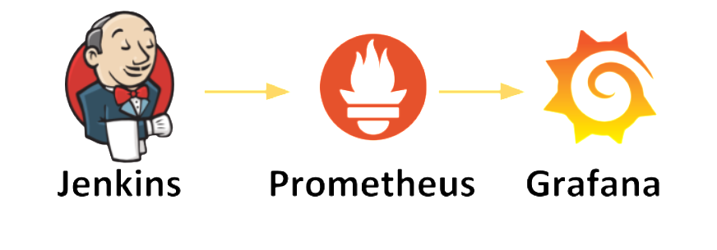

Install the the jenkins in ec2 instances (or) use the existing jenkins server

* Go to jenkins dashboard
* Go to manage jenkins
* Go to manage plugins
* Go to available section search for the Prometheus plugin
* And install it and restart the jenkins
* This plugin receives data from Jenkins Server along with metrics and allows us to view it with the **/prometheus** endpoint.
* Try to build the old job in Jenkins so that you will see the graph of the Jenkins
* You take public_ip of Jenkins:8080/prometheus link for plugin outputs.

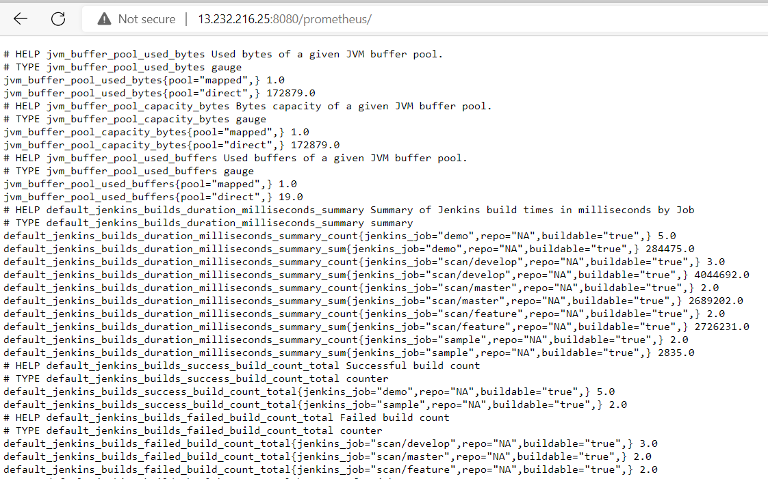

* In order to configure Prometheus, we need to edit the

**prometheus.yml**file.

* Edit /etc/prometheus/prometheus.yml file.

sudo vi /etc/prometheus/prometheus.yml

(and copy paste the code)

global:

scrape_interval: 15s

external_labels:

monitor: 'prometheus'

- job_name: 'jenkins'  
 metrics_path: /prometheus  
 scheme : http  
 static_configs:

- targets: ['public_ip:8080']

* Restart Prometheus service.

sudo systemctl restart prometheus

* Refresh the prometheus dashbord and go to status section
* In status section click on the targets
* You will see the below image all the services attached to the prometheus are in up codition

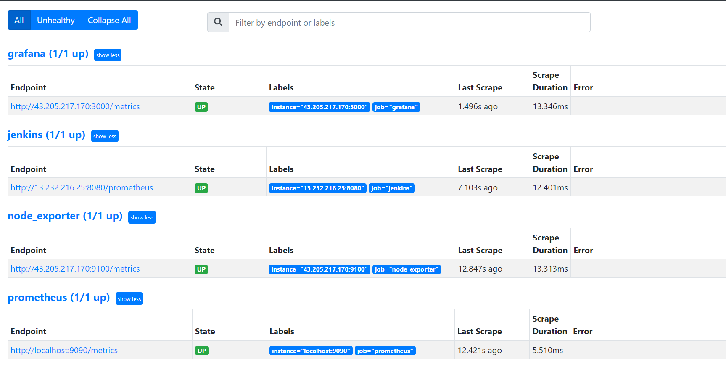

Go to the dashboard of prometheus and create a dashboard

In the serach bar enter the queries of jenkins and click on the execute

You can see the below image as an reference

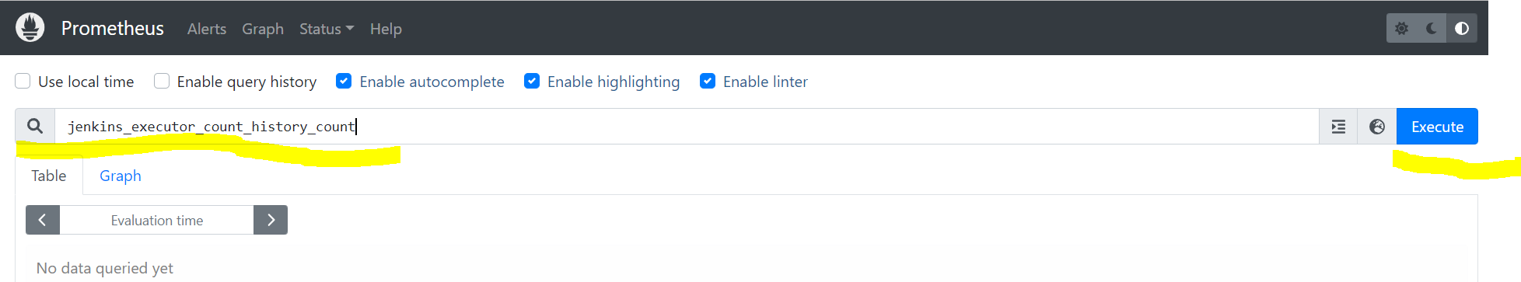

You can see the output as in table and grap format

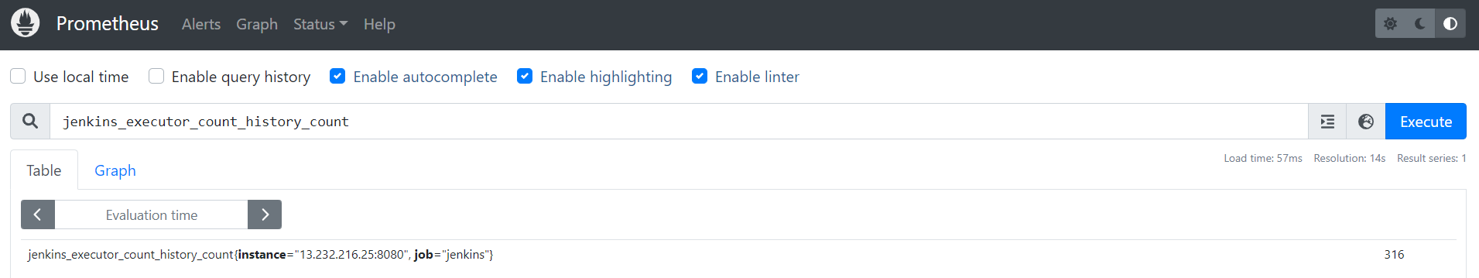

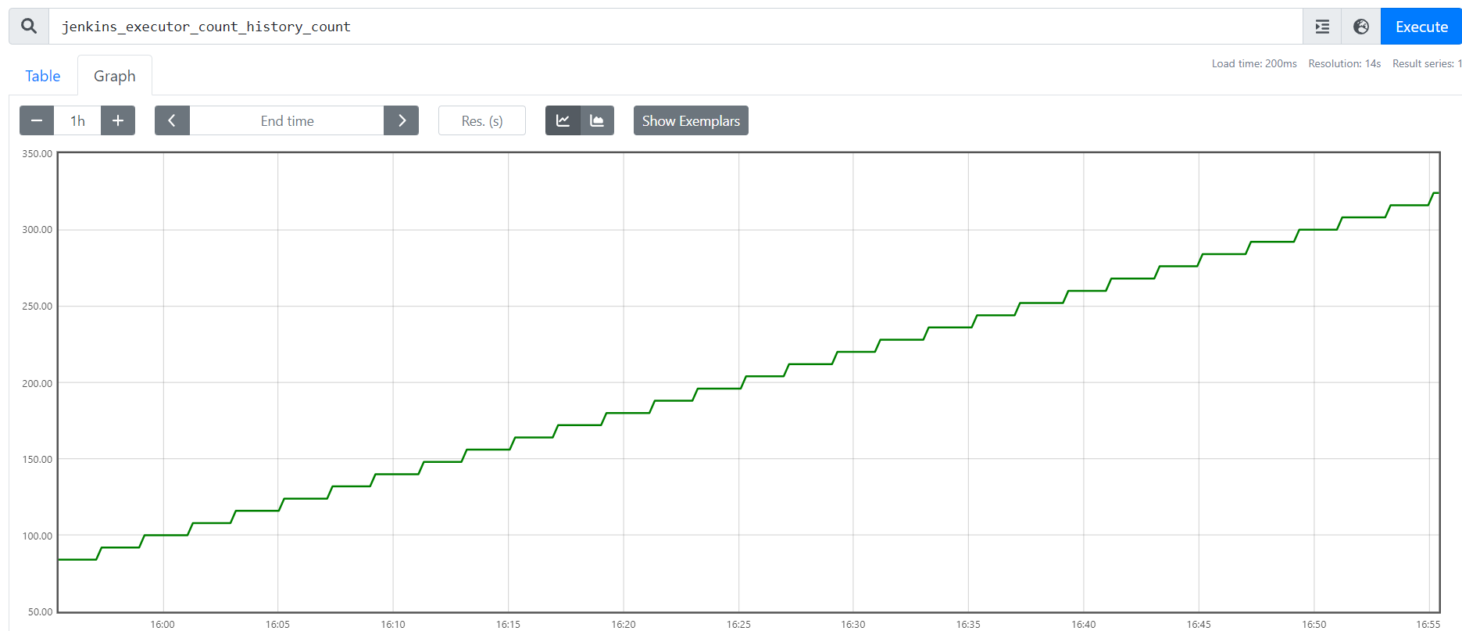

Go to dashboard of the grafana with public_ip:3000

Go to add your data source section

Click on the prometheus enter the in url section <http://public_ip> of prometheus:9090 .

Leave the other option default and click on save and test

Go to home page or dashboard of grafana

Go to the create your dashboard section

Create a new panel and you can see the image as reference

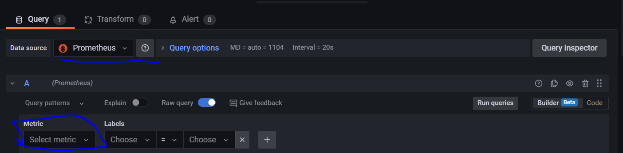

Click on the select metrics of jenkins queries and click on run queries below is the image of it

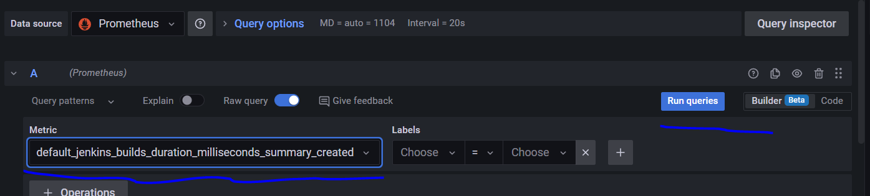

Below one is sample dashboard of queries

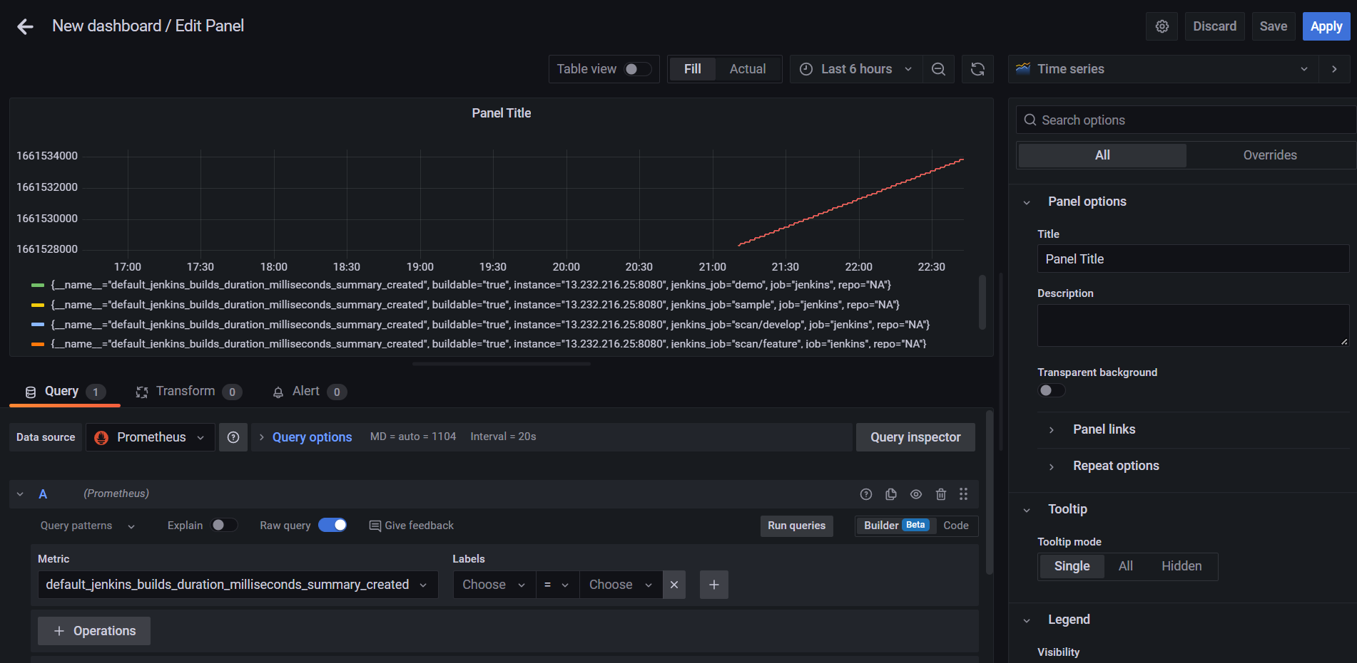

You can save the dashboard give a name to it can create as many dashboards .